LAMPIRAN

Tampilan – Tampilan Web
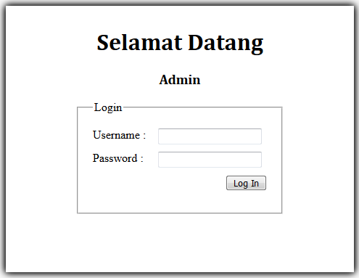
Halaman Login

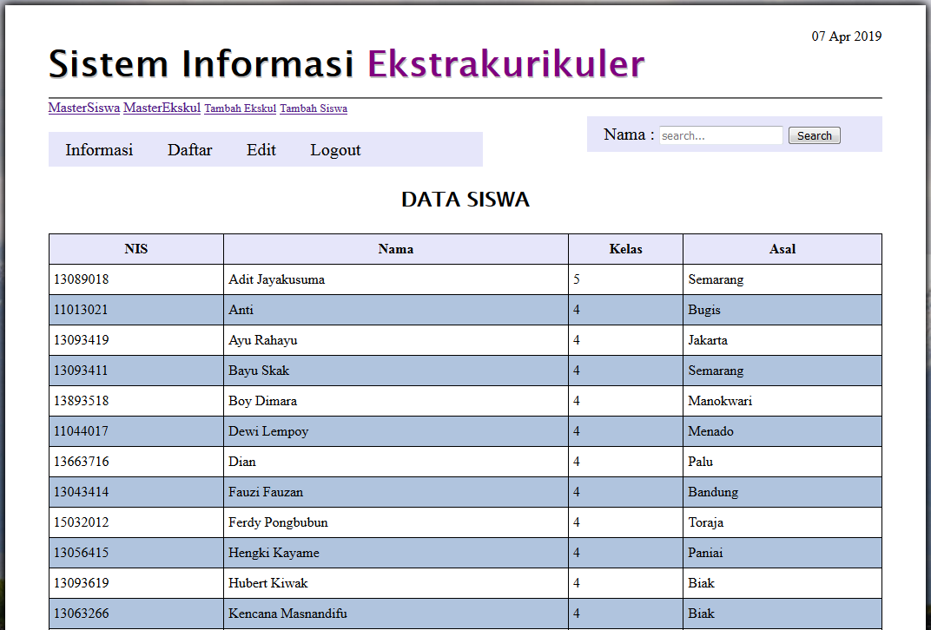
Halaman MasterSiswa

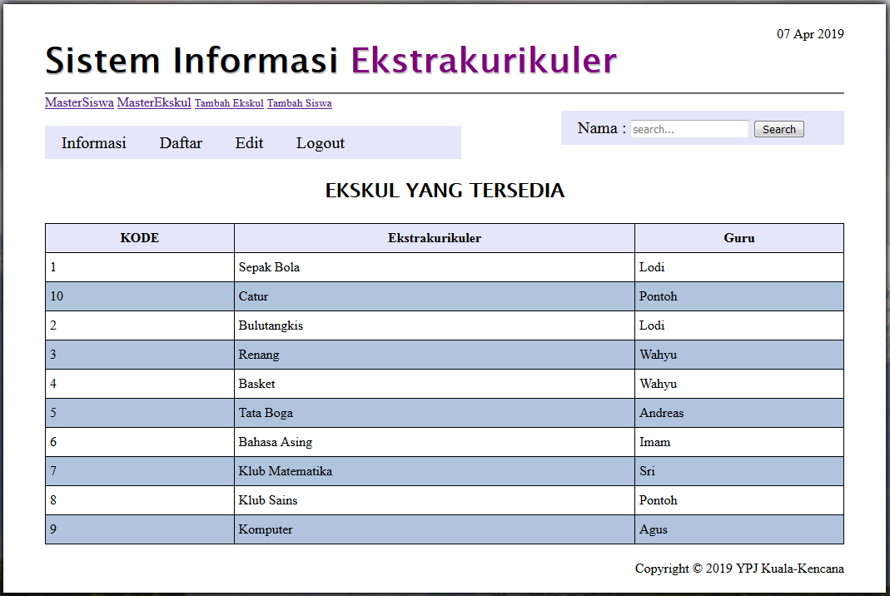
Halaman MasterEkskul

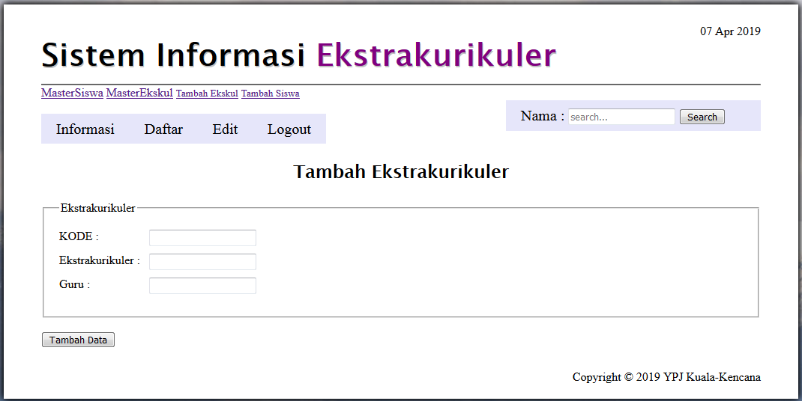
Halaman Daftar Ekskul

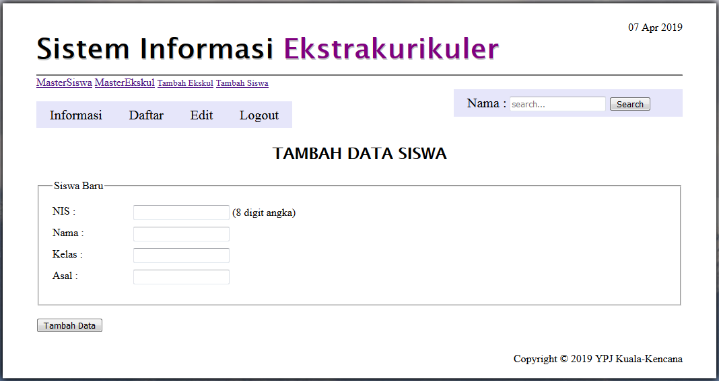
Halaman Tambah Siswa

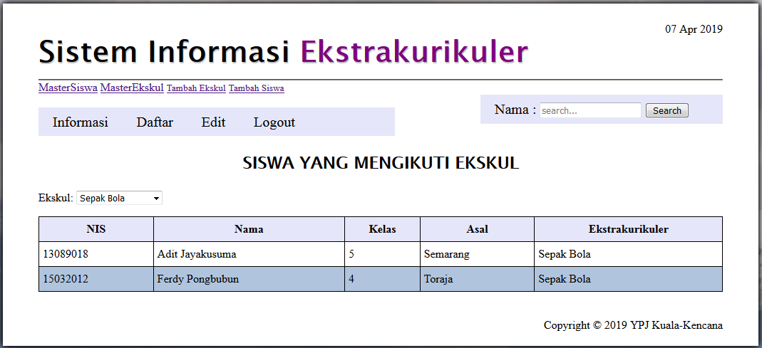
Halaman Informasi

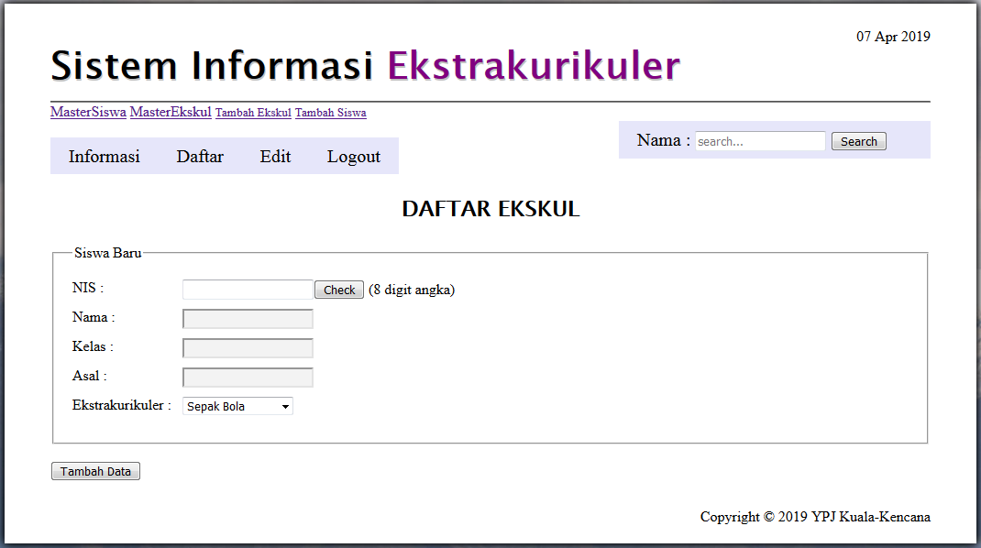
Halaman Daftar

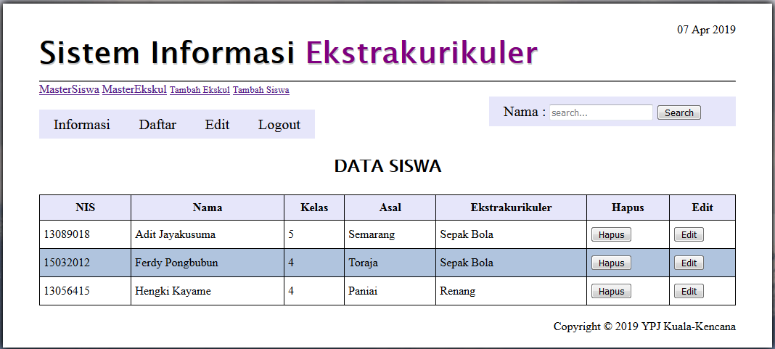
Halaman Edit

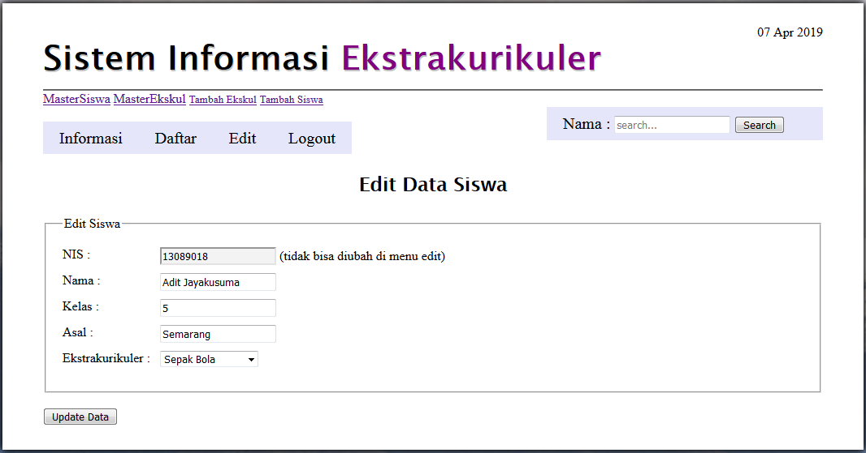
Halaman Form Edit

Listing Program
login.php :
<?php
if (isset($_GET["pesan"])) {
$pesan = $_GET["pesan"];
}

if (isset($_POST["submit"])) {

$username = htmlentities(strip_tags(trim($_POST["username"])));
$password = htmlentities(strip_tags(trim($_POST["password"])));

$pesan_error = "";

if (empty($username)) {
$pesan_error .= "Username belum diisi <br>";
}

if (empty($password)) {
$pesan_error .= "Password belum diisi <br>";
}

include("koneksi.php");

$username = mysqli_real_escape_string($link, $username);
$password = mysqli_real_escape_string($link, $password);

$password_sha1 = sha1($password);

$query = "SELECT * FROM admin WHERE username = '$username'
AND password = '$password_sha1'";
$result = mysqli_query($link, $query);

if (mysqli_num_rows($result) == 0) {

$pesan_error .= "Username dan/atau Password tidak sesuai";
}

mysqli_free_result($result);

mysqli_close($link);

if ($pesan_error === "") {
session_start();
$_SESSION["nama"] = $username;
header("Location: daftar_siswa.php");
}
} else {
$pesan_error = "";
$username = "";
$password = "";
}
?>

tampil_siswa.php (MasterSiswa) :
<?php
session_start();
if (!isset($_SESSION["nama"])) {
header("Location: login.php");
}

include("koneksi.php");
if (isset($_GET["pesan"])) {
$pesan = $_GET["pesan"];
}

if (isset($_GET["submit"])) {

$nama = htmlentities(strip_tags(trim($_GET["nama"])));
$nama = mysqli_real_escape_string($link, $nama);

$query = "SELECT * FROM mastersiswa WHERE nama LIKE '%$nama%' ";
$query .= "ORDER BY nama ASC";
$pesan = "Hasil pencarian untuk nama <b>\"$nama\" </b>:";
} else {
$query = "SELECT * FROM mastersiswa ORDER BY nama ASC";
}
?>

tampil_ekskul.php (MasterEkskul) :
<?php
session_start();
if (!isset($_SESSION["nama"])) {
header("Location: login.php");
}

include("koneksi.php");

if (isset($_GET["pesan"])) {
$pesan = $_GET["pesan"];
}

if (isset($_GET["submit"])) {

$nama = htmlentities(strip_tags(trim($_GET["nama"])));

$nama = mysqli_real_escape_string($link, $nama);

$query = "SELECT * FROM mastersiswa WHERE nama LIKE '%$nama%' ";
$query .= "ORDER BY nama ASC";

$pesan = "Hasil pencarian untuk nama <b>\"$nama\" </b>:";
} else {
masterekskul
$query = "SELECT * FROM masterekskul ORDER BY kode ASC";
}
?>

tambah_ekskul.php (Tambah Ekskul) :
<?php
session_start();
if (!isset($_SESSION["nama"])) {
header("Location: login.php");
}

include("koneksi.php");
if (isset($_POST["submit"])) {

$kode = htmlentities(strip_tags(trim($_POST["kode"])));
$ekstrakurikuler = htmlentities(strip_tags(trim($_POST["ekstrakurikuler"])));
$guru = htmlentities(strip_tags(trim($_POST["guru"])));

$pesan_error = "";
if (empty($kode)) {
$pesan_error .= "Kode belum diisi <br>";
}
if (empty($ekstrakurikuler)) {
$pesan_error .= "Ekstrakurikuler belum diisi <br>";
}

if (empty($guru)) {
$pesan_error .= "Guru belum diisi <br>";
}
$kode = mysqli_real_escape_string($link, $kode);
$query = "SELECT * FROM masterekskul WHERE kode='$kode'";
$hasil_query = mysqli_query($link, $query);

$jumlah_data = mysqli_num_rows($hasil_query);
if ($jumlah_data >= 1) {
$pesan_error .= "Kode yang sama sudah digunakan <br>";
}
$kode = mysqli_real_escape_string($link, $kode);
$query = "SELECT * FROM masterekskul WHERE ekstrakurikuler='$ekstrakurikuler'";
$hasil_query = mysqli_query($link, $query);

$jumlah_data = mysqli_num_rows($hasil_query);
if ($jumlah_data >= 1) {
$pesan_error .= "Ekstrakurikuler yang sama sudah digunakan <br>";
}

if ($pesan_error === "") {

$kode = mysqli_real_escape_string($link, $kode);
$ekstrakurikuler = mysqli_real_escape_string($link, $ekstrakurikuler);
$guru = mysqli_real_escape_string($link, $guru);

$query = "INSERT INTO masterekskul VALUES ";
$query .= "('$kode','$ekstrakurikuler','$guru')";
$result = mysqli_query($link, $query);

if ($result) {
$pesan = "siswa dengan nama = \"<b>$kode</b>\" sudah berhasil di tambah";
$pesan = urlencode($pesan);
header("Location: tampil_ekskul.php?pesan={$pesan}");
} else {
die("Query gagal dijalankan: " . mysqli_errno($link) .
" - " . mysqli_error($link));
}
}
} else {
$pesan_error = "";
$kode = "";
$ekstrakurikuler = "";
$guru = "";
}
?>

tambah_siswa.php (Tambah Siswa) :
<?php
session_start();
if (!isset($_SESSION["nama"])) {
header("Location: login.php");
}

include("koneksi.php");

if (isset($_POST["submit"])) {

$nis = htmlentities(strip_tags(trim($_POST["nis"])));
$nama = htmlentities(strip_tags(trim($_POST["nama"])));
$kelas = htmlentities(strip_tags(trim($_POST["kelas"])));
$asal = htmlentities(strip_tags(trim($_POST["asal"])));

$pesan_error = "";

if (empty($nis)) {
$pesan_error .= "NIS belum diisi <br>";
}
elseif (!preg_match("/^[0-9]{8}$/", $nis)) {
$pesan_error .= "NIS harus berupa 8 digit angka <br>";
}

$nis = mysqli_real_escape_string($link, $nis);
$query = "SELECT * FROM mastersiswa WHERE nis='$nis'";
$hasil_query = mysqli_query($link, $query);

$jumlah_data = mysqli_num_rows($hasil_query);
if ($jumlah_data >= 1) {
$pesan_error .= "NIS yang sama sudah digunakan <br>";
}

if (empty($nama)) {
$pesan_error .= "Nama belum diisi <br>";
}

if (empty($kelas)) {
$pesan_error .= "Kelas belum diisi <br>";
}

if (empty($asal)) {
$pesan_error .= "Asal belum diisi <br>";
}

if ($pesan_error === "") {
$nis = mysqli_real_escape_string($link, $nis);
$nama = mysqli_real_escape_string($link, $nama);
$kelas = mysqli_real_escape_string($link, $kelas);
$asal = mysqli_real_escape_string($link, $asal);

$query = "INSERT INTO mastersiswa VALUES ";
$query .= "('$nis', '$nama', '$kelas', ";
$query .= "'$asal')";

$result = mysqli_query($link, $query);

if ($result) {
$pesan = "siswa dengan nama = \"<b>$nama</b>\" sudah berhasil di tambah";
$pesan = urlencode($pesan);
header("Location: tampil_siswa.php?pesan={$pesan}");
} else {
die("Query gagal dijalankan: " . mysqli_errno($link) .
" - " . mysqli_error($link));
}
}
} else {
$pesan_error = "";
$nis = "";
$nama = "";
$kelas = "";
$asal = "";
}
?>

informasi.php (Informasi) :
<?php
session_start();
if (!isset($_SESSION["nama"])) {
header("Location: login.php");
}

include("koneksi.php");

if (isset($_GET["pesan"])) {
$pesan = $_GET["pesan"];
}

if (isset($_GET["submit"])) {

$daftar = htmlentities(strip_tags(trim($_GET["daftar"])));
$daftar = mysqli_real_escape_string($link, $daftar);

$query = "SELECT * FROM daftarsiswa WHERE nama LIKE '%$daftar%' ";
$query .= "ORDER BY nama ASC";

$pesan = "Hasil pencarian untuk daftar <b>\"$daftar\" </b>:";
} else {
$query = "SELECT * FROM daftarsiswa ORDER BY kelas ASC";
}
?>

daftar_siswa.php (Daftar) :
<?php
session_start();
if (!isset($_SESSION["nama"])) {
header("Location: login.php");
}

include("koneksi.php");

if (isset($_POST["submit"])) {
$nis = htmlentities(strip_tags(trim($_POST["nis"])));
$nama = htmlentities(strip_tags(trim($_POST["nama"])));
$kelas = htmlentities(strip_tags(trim($_POST["kelas"])));
$asal = htmlentities(strip_tags(trim($_POST["asal"])));
$ekstrakurikuler = htmlentities(strip_tags(trim($_POST["ekstrakurikuler"])));

$pesan_error = "";

if (empty($nis)) {
$pesan_error .= "NIS belum diisi <br>";
}
elseif (!preg_match("/^[0-9]{8}$/", $nis)) {
$pesan_error .= "NIS harus berupa 8 digit angka <br>";
}

$nis = mysqli_real_escape_string($link, $nis);
$query = "SELECT * FROM daftarsiswa WHERE nis='$nis'";
$hasil_query = mysqli_query($link, $query);

$jumlah_data = mysqli_num_rows($hasil_query);
if ($jumlah_data >= 1) {
$pesan_error .= "NIS yang sama sudah digunakan <br>";
}

if (empty($nama)) {
$pesan_error .= "Nama belum diisi <br>";
}

if (empty($kelas)) {
$pesan_error .= "Kelas belum diisi <br>";
}

if (empty($asal)) {
$pesan_error .= "Asal belum diisi <br>";
}

if ($pesan_error === "") {
$nis = mysqli_real_escape_string($link, $nis);
$nama = mysqli_real_escape_string($link, $nama);
$kelas = mysqli_real_escape_string($link, $kelas);
$asal = mysqli_real_escape_string($link, $asal);
$ekstrakurikuler = mysqli_real_escape_string($link, $ekstrakurikuler);

$query = "INSERT INTO daftarsiswa VALUES ";
$query .= "('$nis', '$nama', '$kelas', ";
$query .= "'$asal','$ekstrakurikuler')";
$result = mysqli_query($link, $query);

if ($result) {
$pesan = "siswa dengan nama = \"<b>$nama</b>\" sudah berhasil di tambah";
$pesan = urlencode($pesan);
header("Location: hapus_siswa.php?pesan={$pesan}");
} else {
die("Query gagal dijalankan: " . mysqli_errno($link) .
" - " . mysqli_error($link));
}
}
} else {
$pesan_error = "";
$nis = "";
$nama = "";
$kelas = "";
$asal = "";
$ekstrakurikuler = "";
}

if (isset($_POST["submitcheck"])) {
if ($_POST["submitcheck"] == "Check") {
$nis = htmlentities(strip_tags(trim($_POST["nis"])));
$nis = mysqli_real_escape_string($link, $nis);

$query = "SELECT * FROM mastersiswa WHERE nis='$nis'";
$result = mysqli_query($link, $query);

$jumlah_data = mysqli_num_rows($result);
if ($jumlah_data < 1) {
$pesan_error .= "NIS TAK DIKENALI!!! <br>";
}

if (!$result) {
die("Query Error: " . mysqli_errno($link) .
" - " . mysqli_error($link));
}

$data = mysqli_fetch_assoc($result);

$nama = $data["nama"];
$kelas = $data["kelas"];
$asal = $data["asal"];
mysqli_free_result($result);
}
}
?>

hapus_siswa.php (Edit) :
<?php
session_start();
if (!isset($_SESSION["nama"])) {
header("Location: login.php");
}

include("koneksi.php");

if (isset($_POST["submit"])) {
$nis = htmlentities(strip_tags(trim($_POST["nis"])));
$nis = mysqli_real_escape_string($link, $nis);

$query = "DELETE FROM daftarsiswa WHERE nis='$nis' ";
$hasil_query = mysqli_query($link, $query);

if ($hasil_query) {
$pesan = "siswa dengan nis = \"<b>$nis</b>\" sudah berhasil di hapus";
$pesan = urlencode($pesan);
header("Location: hapus_siswa.php?pesan={$pesan}");
} else {
die("Query gagal dijalankan: " . mysqli_errno($link) .
" - " . mysqli_error($link));
}
}
?>

form_edit_siswa.php (Form Edit) :
<?php
session_start();
if (!isset($_SESSION["nama"])) {
header("Location: login.php");
}

include("koneksi.php");

if (isset($_POST["submit"])) {

if ($_POST["submit"] == "Edit") {

$nis = htmlentities(strip_tags(trim($_POST["nis"])));
$nis = mysqli_real_escape_string($link, $nis);

$query = "SELECT * FROM daftarsiswa WHERE nis='$nis'";
$result = mysqli_query($link, $query);

if (!$result) {
die("Query Error: " . mysqli_errno($link) .
" - " . mysqli_error($link));
}

$data = mysqli_fetch_assoc($result);

$nama = $data["nama"];
$kelas = $data["kelas"];
$asal = $data["asal"];
$ekstrakurikuler = $data["ekstrakurikuler"];

mysqli_free_result($result);
} else if ($_POST["submit"] == "Update Data") {
$nis = htmlentities(strip_tags(trim($_POST["nis"])));
$nama = htmlentities(strip_tags(trim($_POST["nama"])));
$kelas = htmlentities(strip_tags(trim($_POST["kelas"])));
$asal = htmlentities(strip_tags(trim($_POST["asal"])));
$ekstrakurikuler = htmlentities(strip_tags(trim($_POST["ekstrakurikuler"])));
}

$pesan_error = "";

if (empty($nis)) {
$pesan_error .= "NIS belum diisi <br>";
}
elseif (!preg_match("/^[0-9]{8}$/", $nis)) {
$pesan_error .= "nis harus berupa 8 digit angka <br>";
}

if (empty($nama)) {
$pesan_error .= "Nama belum diisi <br>";
}

if (empty($kelas)) {
$pesan_error .= "Kelas belum diisi <br>";
}

if (empty($asal)) {
$pesan_error .= "Asal belum diisi <br>";
}

if (($pesan_error === "") and ($_POST["submit"] == "Update Data")) {

include("koneksi.php");

$nis = mysqli_real_escape_string($link, $nis);
$nama = mysqli_real_escape_string($link, $nama);
$kelas = mysqli_real_escape_string($link, $kelas);
$asal = mysqli_real_escape_string($link, $asal);
$ekstrakurikuler = mysqli_real_escape_string($link, $ekstrakurikuler);

$query = "UPDATE daftarsiswa ";
$query .= "SET nama = '$nama', kelas = '$kelas', ";
$query .= "asal = '$asal', ekstrakurikuler='$ekstrakurikuler' ";
$query .= "WHERE nis = '$nis'";

$result = mysqli_query($link, $query);

$query = "UPDATE mastersiswa ";
$query .= "SET nama = '$nama', kelas = '$kelas', ";
$query .= "asal = '$asal' ";
$query .= "WHERE nis = '$nis'";

$result = mysqli_query($link, $query);

if ($result) {
$pesan = "Siswa dengan nama = \"<b>$nama</b>\" sudah berhasil di update";
$pesan = urlencode($pesan);
header("Location: hapus_siswa.php?pesan={$pesan}");
} else {
die("Query gagal dijalankan: " . mysqli_errno($link) .
" - " . mysqli_error($link));
}
}
} else {
header("Location: hapus_siswa.php");
}
?>

Sampel Kuisioner
